|  |
| --- |
|  |
| **Implementing a small office Network** |
| Khaled FarghalyMohamed KhaledMohamed MahmoudYasseen Tarek |
| **(ONL1_ISS2-S1e)** Cisco Network AdministartionEng Amr Reda |

Table of Contents

1. Introduction 1-2

2. Understanding Network Requirements 1-2

2.1 Number of Users **Error! Bookmark not defined.**

2.2 Devices **Error! Bookmark not defined.**

3. Basic Network Components **Error! Bookmark not defined.**

3.1 Router **Error! Bookmark not defined.**

3.2 Switch **Error! Bookmark not defined.**

3.3 Network Cables **Error! Bookmark not defined.**

3.4 Server **Error! Bookmark not defined.**

4. Network Design **Error! Bookmark not defined.**

4.1 Topology **Error! Bookmark not defined.**

4.2 IP Addressing **Error! Bookmark not defined.**

4.3 Subnetting **Error! Bookmark not defined.**

5. Network Security 4-5

5.1 OSPF **Error! Bookmark not defined.**

5.2 EIGRP **Error! Bookmark not defined.**

5.3 VPN (Virtual Private Network) **Error! Bookmark not defined.**

6. Network Setup Process **Error! Bookmark not defined.**

6.1 Step-by-Step Installation **Error! Bookmark not defined.**

6.1.1 Internet Connection Setup **Error! Bookmark not defined.**

6.1.2 Wiring and Device Setup **Error! Bookmark not defined.**

6.1.3 Router and Switch Configuration **Error! Bookmark not defined.**

6.1.4 Wireless Network Setup **Error! Bookmark not defined.**

6.1.5 Testing **Error! Bookmark not defined.**

7. Network Maintenance and Monitoring 7-8

7.1 Regular Monitoring **Error! Bookmark not defined.**

7.2 Backup and Recovery **Error! Bookmark not defined.**

7.3 Scalability **Error! Bookmark not defined.**

8. Network Maintenance and Monitoring **Error! Bookmark not defined.**

8.1 Regular Monitoring **Error! Bookmark not defined.**

8.2 Backup and Recovery **Error! Bookmark not defined.**

8.3 Scalability **Error! Bookmark not defined.**

# Introduction

**A reliable and well-designed office network is crucial for any small business as it allows employees to share resources, collaborate efficiently, and access the internet securely. This report outlines the steps and considerations necessary for setting up a small office network, including hardware requirements, software considerations, network design, security, and maintenance.**

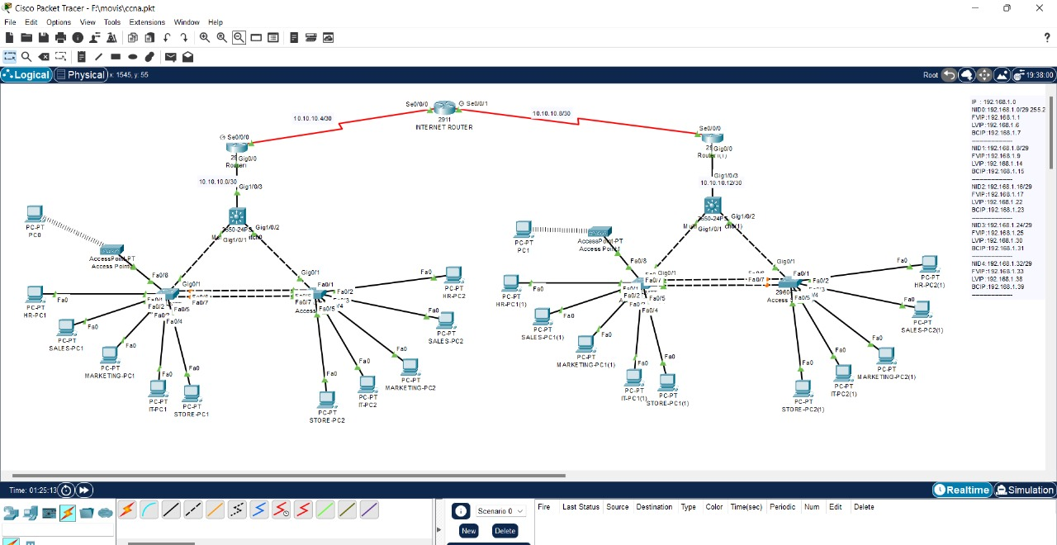

# Understanding of Network Implementations

## Number of users

## The network will be operating with 20 PC`s

## Devices

## Devices will include Routers ,Switches ,Multilayer switches, access points ,Servers and Pc`s

# Basic Network Components

## Router

## The router connects the office network to the internet and manages traffic between internal devices. For small offices, a high-quality business-class router with advanced features such as VLANs, VPN, and firewall capabilities is recommended.

## Switch

## A switch is used to connect multiple devices (PCs, printers, servers) within the network. Managed switches are preferable as they offer control over the network’s configuration and performance.

## 3.3 Network Cables

## Ethernet cables (typically Cat6 or Cat5e) connect devices to the network switch and router. Proper cabling ensures high-speed, stable connections.

# Network Design

## Topolgy

**Star Topology** is the most common setup for small offices, where all devices are connected to a central switch or router. This setup is simple, scalable, and easy to manage.According to network Infrastructure naming convention, we are going to use the following naming schema for our network devices

## IP Addressing

Use **Dynamic Host Configuration Protocol (DHCP)** for automatic IP addressing. The router typically acts as the DHCP server, assigning IP addresses to each connected device.

## Subnetting

## For enhanced security and organization, the network can be divided into subnets. For example, separate networks for management, employees, and guest users can be created.

# Network Security

## OSPF

OSPF requires network segmentation into areas, with one or more core areas (Area 0 or Backbone Area) and additional areas to reduce routing overhead.

## Each area should have a different subnet, and OSPF will dynamically route traffic between them.

## EIGRP

## EIGRP is set up with multiple autonomous systems to facilitate routing between different office segments.

## VPN(virtual private network)

## Implementing VPN allows remote employees to access the network securely over the internet.

## Regular Updates

## Keep all software, including routers, switches, and operating systems, up to date to patch any vulnerabilities.

# Network Setup Process

#### **6.1.1**

#### **a. Step-by-Step Installation**

1. **Internet Connection Setup**:
   * Connect the router to the internet service provider (ISP) modem and configure internet access.

6.1.2 **Wiring and Device Setup**:

* Connect switches, access points, and other hardware devices.
* Run Ethernet cables from each device to the switch/router.

6.1.3 **Router and Switch Configuration**:

* Access the router’s configuration interface (typically via a web browser) to set up the network name (SSID), passwords, DHCP, and firewall settings.

6.1.4 **Wireless Network Setup**:

* Configure access points with the office's wireless SSID and security settings.

6.1.5 **Testing**:

* Test connectivity for all devices (both wired and wireless).
* Ensure all employees have proper access to the network and internet.

# Network Maintenance and Monitoring

7.1 • Use network monitoring tools to track performance, bandwidth usage, and identify potential issues.

• Managed switches and routers often come with monitoring software that can alert administrators to problems such as traffic bottlenecks or unauthorized access.

7.2 • Implement a backup solution to regularly back up critical data, preferably off-site or using cloud services.

• Ensure that a recovery plan is in place to restore the network quickly in case of failure or data loss

7.3 Design the network with scalability in mind to accommodate future growth. Ensure that switches and routers have sufficient capacity for additional devices or bandwidth requirements.

